

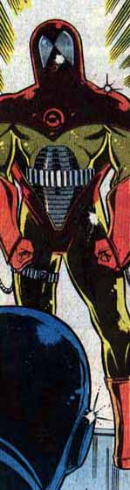
Sunturion
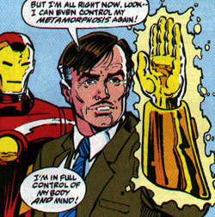
Real Name: Arthur Dearborn. There was a second Sunturion, Mike Stone, who evaporated during his initial appearance in DareDevil 224 and seems to have remained evaporated.
First Appearance: Iron Man 143
Molecules Dispersed in: Iron Man 144
Molecules Re-Obtained Cohesiveness In: Iron Man Annual 9. Knowing that energy could never be truly destroyed, Roxxon worked to pull Sunturion back together so he could join Iron Man in the fight against anti-Roxxon terrorist Stratosfire. Absorbing part of the impact of Roxxon's Zed control blast developed to neutralize Stratosfire, Dearborn reverted to being human whilst in mid-air and had to be rescued by Iron Man. The Ghost accidently regenerated Dearborn's powers when he used a microwave-based weapon on the scientist.
What's His Problem? Fearing that the next World War would be fought over dwindling fossil fuels, Dearborn began to search for an alternate form of energy. When his proposal for a space-station to conduct solar energy experiments was rejected as too expensive, he submitted to a Brand Corporation experiment that altered his physical form into microwave energy. In this form he could become the entire staff of the proposed station, slashing the budget. Accepting money from his employer, Roxxon, Dearborn set up Star Well, a radar-shielded space station, and continued his solar experiments in the hopes of discovering a viable world-wide energy source. Unfortunately the experiment occasionally got away from him...
Abilities: As a being composed completely of microwave energy, Sunturion can absorb energy and reflect it back at its source as well as transmit himself almost instantaneously across the planet.
Heroes He Keeps Running Into: Although originally delighted to have Iron Man show up at Star Well -- running a super-secret space station is a lonely job -- Sunturion ended up battling the Avenger when Iron Man insisted on confiscating the station as evidence.
Favorite Quote: "But I thought you understood! The future of this station is worth any sacrifice! Even ... the one I made!" (Iron Man 143)
People Who Think He's Not So Bad: Iron Man admired a great deal about Dearborn, including his goals and his dedication. But the Golden Avenger couldn't contenance the Allantown incident, insisting that Sunturion had to turn himself over to the authorities and that his space station had to be used as evidence against Dearborn's parent company, Roxxon. When Sunturion was re-incorporated, the two became friends; Dearborn even once testified as a character witness for Stark. Dearborn remains devoted to Roxxon.
Most Despicable Act: The destruction of everything living in Allantown; humans, pets, livestock, wildlife, everything; when an overloaded circuit on the space station accidentally sent a concentrated beam of microwave energy to Earth. Sunturion insisted that the sacrifice of a few hundred human lives was worth the eventual goal of unlimited energy; however, when Sarasota, Florida was in danger of being smashed by his collapsing space station, Sunturion sacrificed himself rather than have the deaths of millions on his conscience.

